Final Project: Basic System Design for Crusty Muse Bakery
Instructions: Use this template to complete the tasks in this project.
Task 1: Basic system analysis
A: Identify key stakeholders
Stakeholder | Role
Customer | Views menu items, adds products to cart, places orders
Bakery Staff | Review new incoming orders, prepares items, updates order status.
Bakery Manager/Owner | Oversees operations, check order volume, updates prices, manages product availability.
Payment Processor | Handles secure online payment processing for customer orders.

B. Identify the system components
Use case | Input (what goes into the system) | Process (what the system does with the input) | Output (what comes out of the system)
Status confirmation email to the customer | Customer email address + order status | System generates an email message and formats confirmation details | Confirmation email sent to the customer

Task 2: Select an SDLC model
Choice of SLDC model | Agile
Reason | - Requirements may evolve as the bakery tests the online system.  - Agile allows quick updates (e.g., adding delivery, new menu items, coupons).  - The bakery is small, so frequent feedback cycles from staff and customers are valuable.  - The budget is small, and Agile avoids costly rework by improving the system in small steps.

Task 3: Select the architecture pattern
Choice of architecture pattern | 2-Tier (Client-Server)
Reason | - A small bakery needs a simple, low-cost solution.  - 2-tier architecture is easier to build, deploy, and maintain.  - The traffic is low (20–30 orders/day), so complexity of 3-tier is not necessary.  - Perfect for small business websites where the server can handle both logic and data.  Client: Customer’s and staff’s web browser  Server: Handles UI responses, processes orders, stores data in the database

Task 4: Complete a basic system diagram
 | Component
1 | Customer
2 | Website
3 | Server
4 | Database
5 | Staff Dashboard

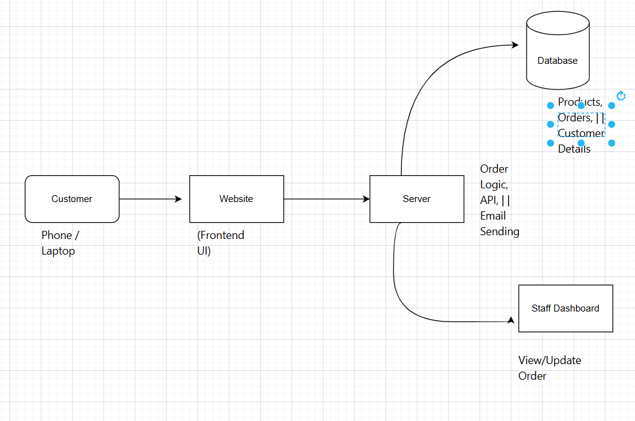
Explanation of Flow
- Customer interacts with the Website.
- The Website sends requests to the Server.
- The Server reads/writes data in the Database.
- Staff Dashboard retrieves order information from the Server.

Task 5: Document your progress in the project
Project summary
Business problem |  | Crusty Muse Bakery currently accepts orders only in person or by phone. This results in delays, manual mistakes, and lost sales because customers cannot order online. The bakery needs a simple digital system that allows customers to place orders online and helps staff track them easily.
System Goal |  | To provide a simple, mobile-friendly online ordering system where customers can browse items, add them to a cart, and place orders, while bakery staff can view and update order status. The system must be low-cost, easy to maintain, and support 20–30 orders per day.
Technical choices
SDLC Model |  | Agile
Reason for the choice |  | Agile allows the bakery to build the system in small parts and adjust it based on feedback. Requirements may change as the bakery tests what works best. Agile avoids expensive rework and supports small-budget, fast-iteration development.
Architecture pattern |  | 2-Tier (Client–Server)
Reason for the choice |  | A 2-tier architecture is simple, cost-effective, and easy to maintain perfect for a small bakery. The client (web browser) handles the UI, while the server manages business logic and the database. The traffic (20–30 orders/day) is small enough that a more complex 3-tier architecture is unnecessary.

